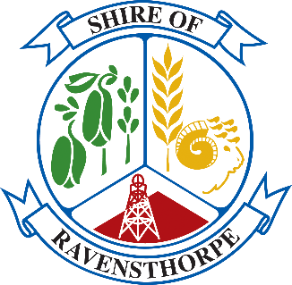

Shire President Donations
Application Form

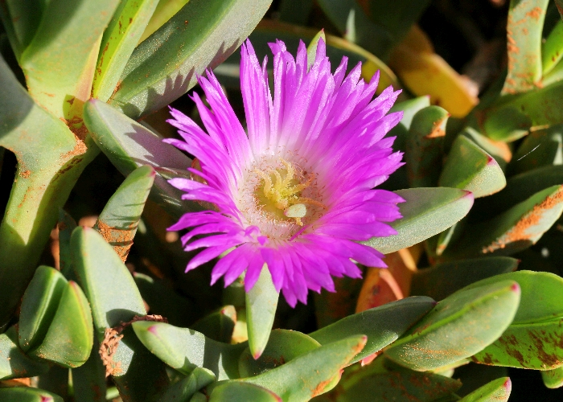

Shire PResident Donations information sheet

Introduction
Small donations up to $750 are available as part of the Shire of Ravensthorpe’s Community Development Fund (CDF) program and are designed to meet funding requests that do not meet the eligibility of the other CDF grant categories being; General Community Grants, Community Events and Major Events funding categories and can be applied for at any time of the year.

Eligibility
Local community groups or individuals (where an individual can demonstrate sufficient justification for the provision of financial assistance) may apply for up to $750 ex GST.
The Donations category is provided to cover any applications that may not qualify for the other stated CDF categories, and may be applied for at any time of the year subject to funds still being available.
Applicants are limited to only apply for one of the four CDF categories in any one year.
Shire President Donations may be considered in addition to applications in other categories under exceptional circumstances as determined by the Shire President.

How to Apply
Applications for Donations may be submitted at any time throughout the year for any purpose.
Applications will be received from Shire based organisations, or individuals, where an individual can demonstrate sufficient justification for the provision of financial assistance. For example, such justification may include selection as a representative on a state or national team, with associated costs.
Council will determine the level of funding allocated to the Shire President Donations category when considering other CDF applications each year.
Requests for Donations will only be considered by the Shire President or by delegated authority to the CEO.
Donations will be considered as long as sufficient funds exist within the CDF budget.
Applicants should complete the Donation application form and attach a formal letter of request addressed to the Shire President for consideration and response.

DONATIONS APPLICATION FORM
Please ensure that you have read the Donations information sheet and completed the below application form. We also recommend you contact the Shire of Ravensthorpe officers to discuss your application before applying.

Contact Information
Contact person | Click or tap here to enter text.
Name of organisation and position (if applicable) | Click or tap here to enter text.
Address | Click or tap here to enter text.
Phone number | Click or tap here to enter text.
Email | Click or tap here to enter text.

Checklist (please mark where appropriate)
I have read the Donation guidelines | ☐
I am/My organisation is eligible to apply for this funding | ☐
Does your organisation have an Australian Business Number? | ☐
Is your organisation registered for GST? | ☐
Has your organisation been granted deductible recipient status? | ☐
Are you an employee or contractor working for the Shire of Ravensthorpe or a close relative? *If yes we will contact you to determine any potential conflict of interest | ☐
Letter of request attached? | ☐

Declaration
I, the undersigned, confirm that I have carefully reviewed and considered the responses and the information provided is true and correct.

Signed: ______________________________ Date: _____________________________

Completed applications should be mailed or submitted in person to:
Shire President
Donation Requests
65 Morgans St Ravensthorpe
Ravensthorpe WA 6346

Electronic submissions should be emailed to shire@ravensthorpe.wa.gov.au with subject line: Donation Request.

